# **Procedure to Download Sentinel-2 Satellite Imagery**

## **Step 1: Visit Website and Signup/ Log-in**

Copernicus Open Access Hub: <https://scihub.copernicus.eu/dhus/#/home>

Click on User Icon on top, then click on Sign up(if new user) else Login with Username and Password.

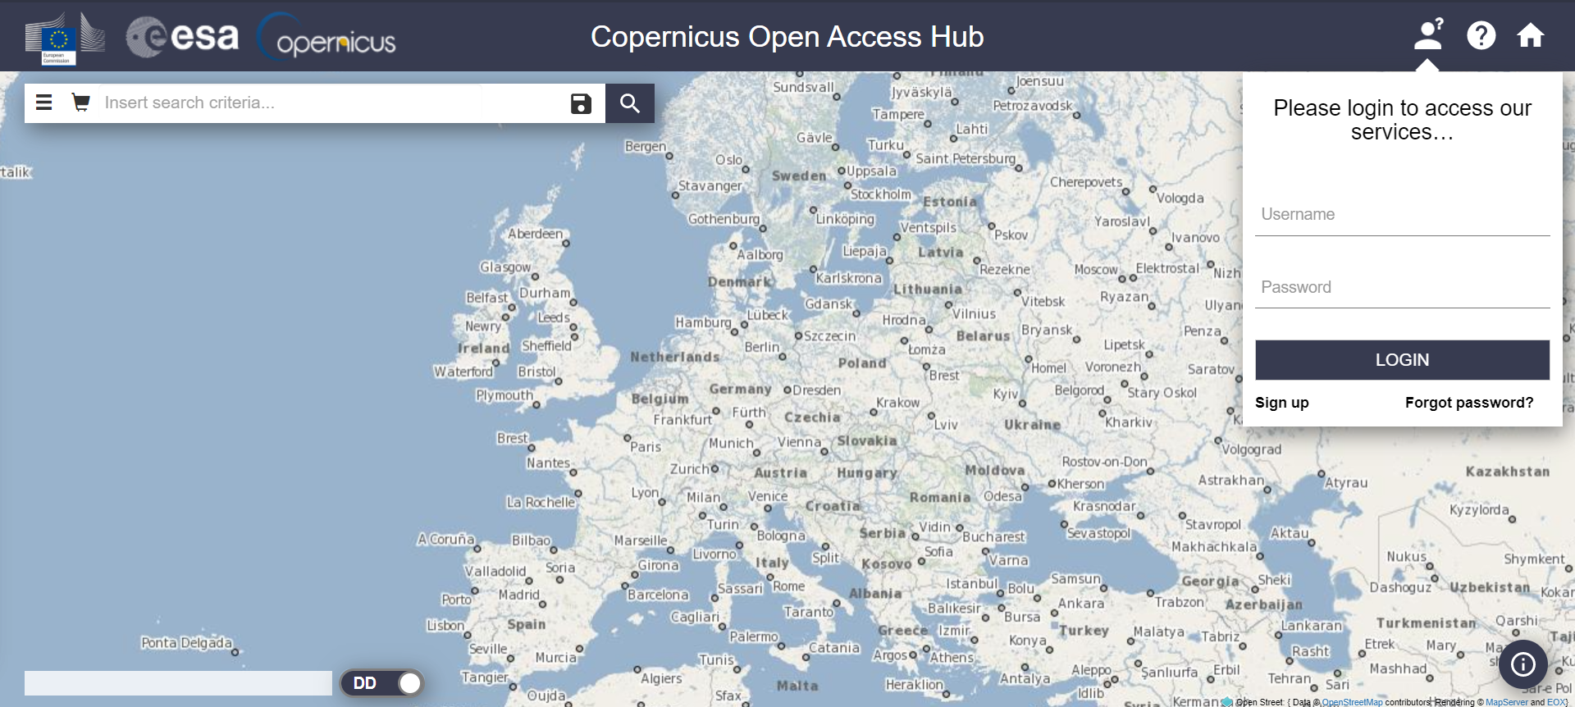

## **Step 2: Choose Area of Interest**

After logging in to your account, click on Map-Layer Icon below the Home Icon on right.

Select the last layer (Sentinel-2 Cloudless + Overlay).

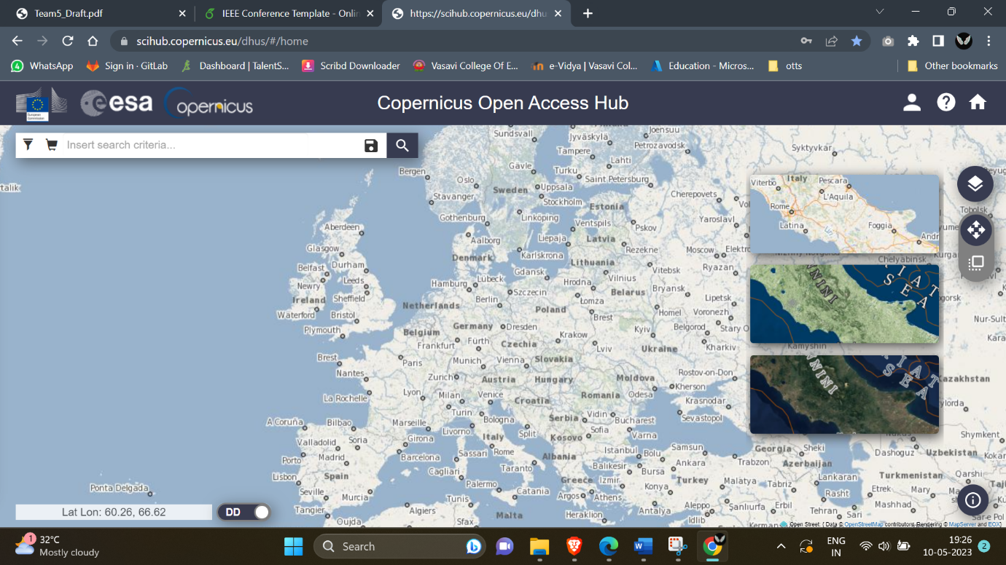

Go to your location in which you are interested, with the help of mouse scroll and click navigation.

Click on Box like icon below the map layers icon, select the “Switch to navigation mode”.

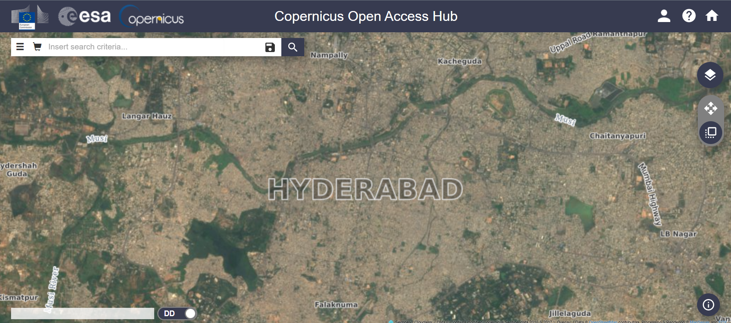

Now with the help of Mouse left clicks draw the desired shape polygon.

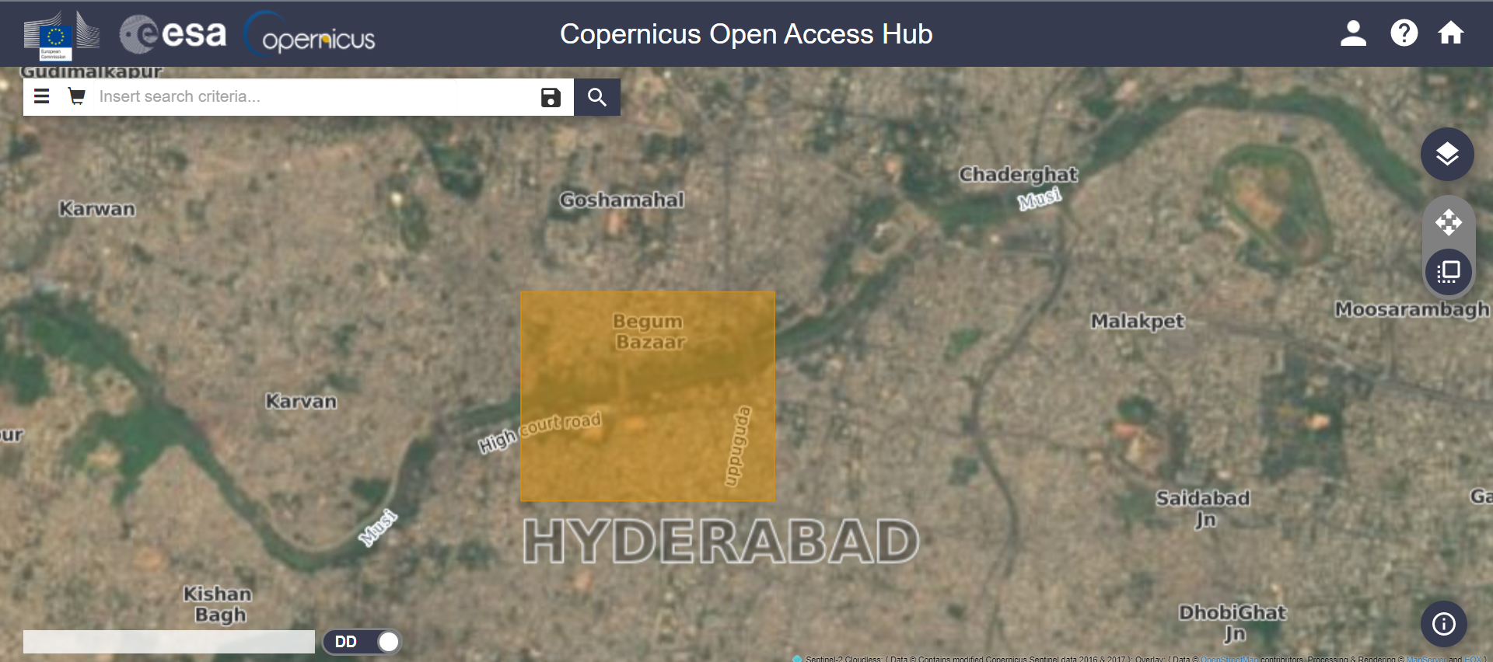

Click on menu icon on top-left corner, in the Advanced Search select

* Sort By = “Sensing Data”
* Order By = “Descending”
* Sensing Period as per requirement (using the calendar icon - start and end date)
* Check the “Mission: Sentinel-2” check box by scrolling down a bit.
* In Mission: Sentinel-2, Select Product Type = ”S2MS12A”, Cloud Cover% = [0 TO 4] (as per requirement)

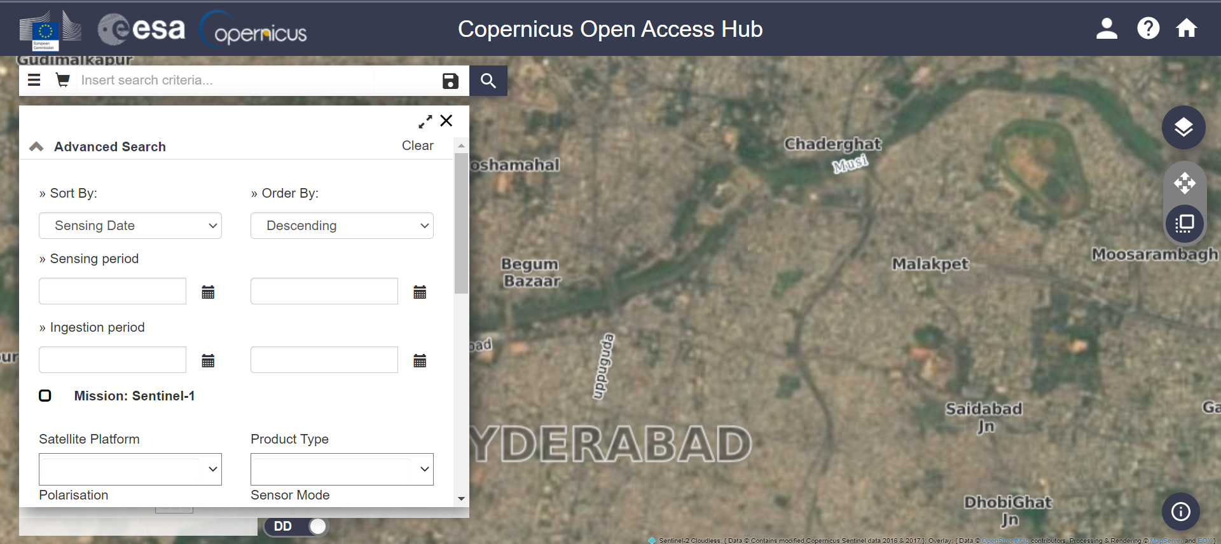

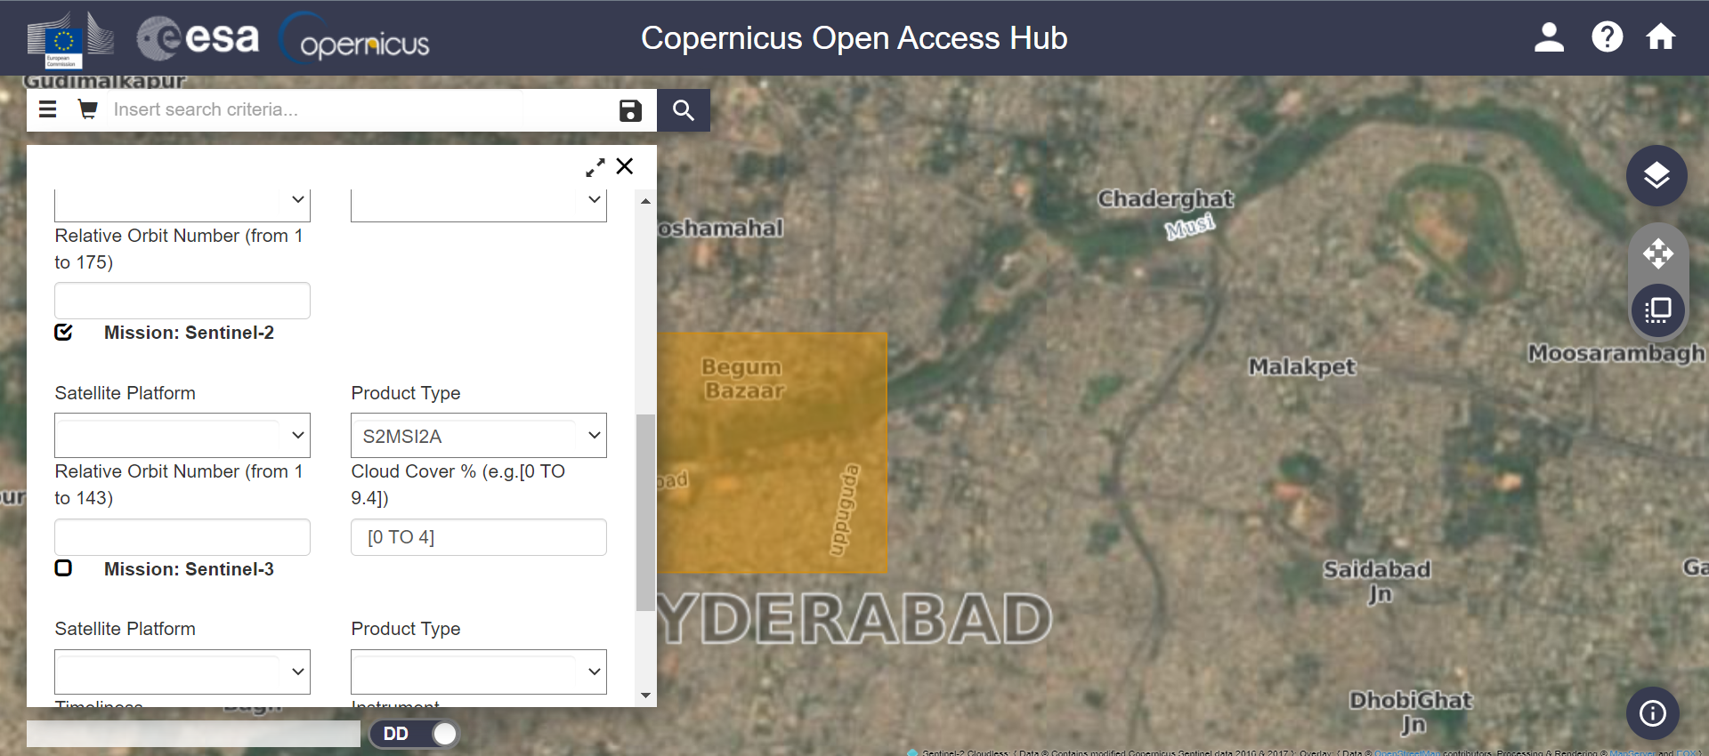

Click Search Icon.

## **Step 3: Downloading Imagery**

After Clicking search icon, you will get the screen like this,

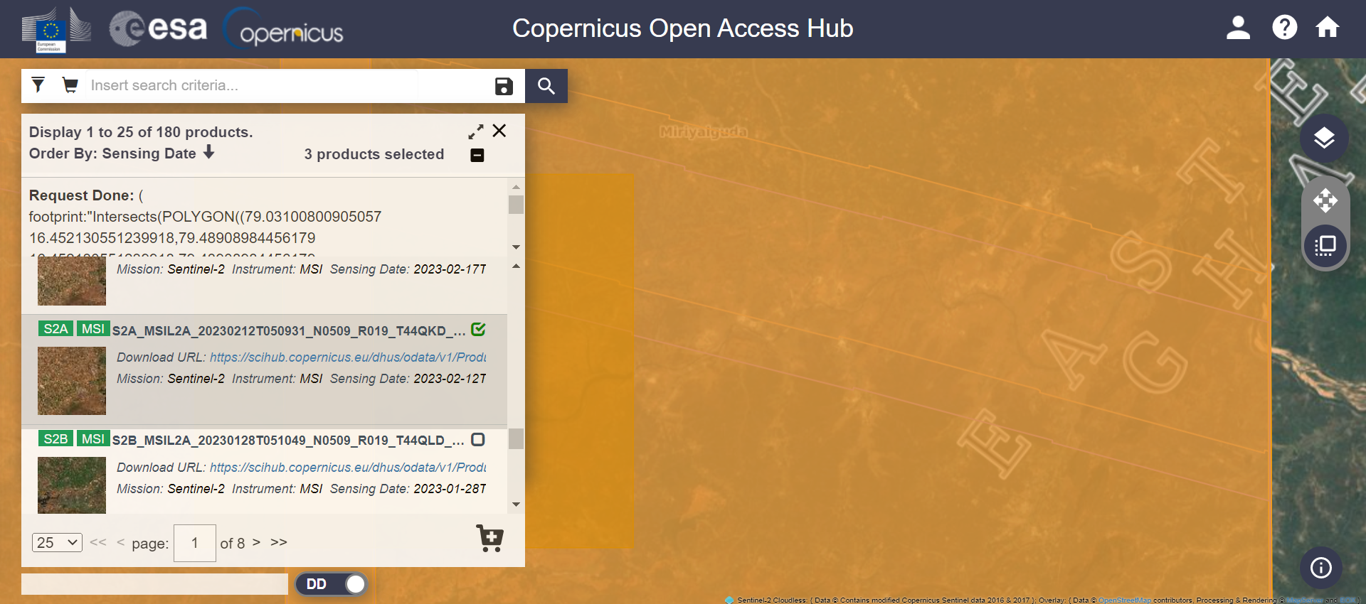

Select any of the Imagery of your choice, click on “eye” icon to preview the imagery.

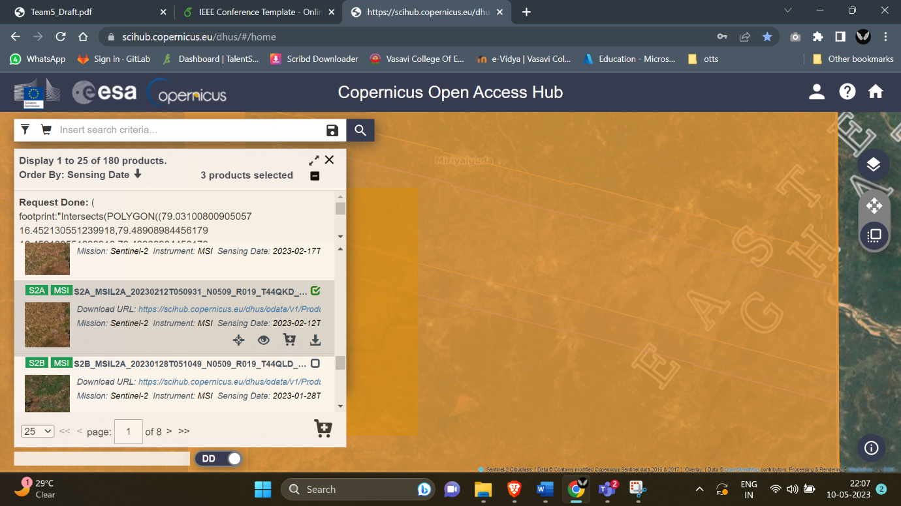

Click on Download icon to down that Imagery as ZIP file.

